# Go Pig or Go Home

A silly racing game about pigs and takings risks. Play the **Olympigs** with 1-6 friends.

It should just be ¾-view in 2D, and people are pigs running over a racetrack? (Like a stadium for athletics in the Olympics.)

Then it’s up to me if I want the game to *only go to the right*, or also swerve in different directions. (Like with *Rolling in the Sheepe*. Only now it’s sorta top-down, which makes it *a lot easier*.)

Obviously, the terrain underneath can change. And the most likely terrain would be **mud/dirt** of course.

Players are locked onto tracks. This makes the controls simple:

* Move up/down the tracks.
* One button for *jump*
* 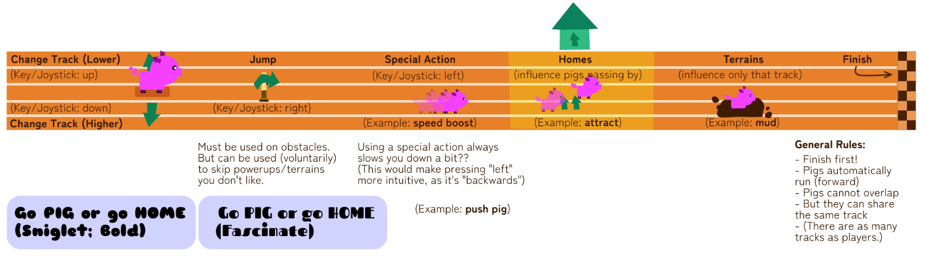One button for *special action*? (Or simply the opposite of jump, *duck*?)

Each mode has its own silly title:

* Go Pig or Go Gnome
* Go Pig or Go Stone
* Go Pig or Snow Cone
* Go Pig or Go Home => basic mode, just a simple race (very short rounds), every time someone is eliminated. *Or*, they are actual homes that pop up, and running into them (by accident) means you’re out of the race?
  + Maybe homes have things like “good smelling food” or “store with discount” which *lures* players to automatically go there.
* Go Pig or Go Drone
* Go Pig or Go Rome
* Go Pig or Go Foam
* Go Pig or Go Phone
* Go Pig or Go Loan
* Go Pig or Go Alone
* Go Pig or Go Blown
* Go Pig or Go Flown
* Go Pig or Go Roam

(Make this the campaign as well? So each level has a title like this, which is also the unique element being added?)

Should have some *main mechanic* or *unique rule* that has to do with:

* The meaning of the saying (“Go big or go home”)
* Pigs and how they look/work
* Becoming/being *big*

Can you **crash**? (Maybe by default you just can’t overlap. But if you bump into someone *fast enough*, or you have a certain *powerup/state*, it causes a crash?)

**Trailer:** show a match (or a collection of matches) and *cast* it like it’s a real, important, exciting Olympics match. (Take cliché sentences from Rocket League, Trackmania or Soccer casting.)

When it switches to a different game, do something like:

* Caster 1: “Woah, the whole game just changed!”
* Caster 2: “Nah, that’s just for the trailer.”
* Caster 1: ”Ah – alright.”